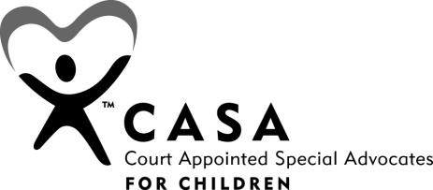
Case No. |  |  | CASA:
For the Honorable
Mother’s Name
Date of Hearing
ICWA Case (Y/N)
Child’s Name | Age | Father’s Name |  | Length of Time  In Foster Care | Number of  Placements

HISTORY

RECORDS REVIEWED

SUMMARY OF INTERVIEWS
Date, Name and Relationship to Child

NEEDS AND WISHES OF THE CHILD

Child Placement.
Child Behavior.
Child Development.
Education.
Medical.
Visitation.

FAMILY SUPPORTS AND STRENGTHS

CONCERNS

RECOMMENDATIONS

Respectfully submitted,
CASA’s full Name
Court Appointed Special Advocate

cc: Child Welfare Caseworker –
Tribal Caseworker -
Attorney for Children -
Attorney for Mother -
Attorney for Father -

Approved by:
CASA Program Coordinator’s full Name
CASA Program Coordinator

